Software Requirements Specification

Version 1.0

<<Annotated Version>>

May 11, 2021

e-commerce system

Nidal Bakir

George Salloum

Sami Ghamika

<<Any comments inside double brackets such as these are *not* part of this SRS but are comments upon this SRS example to help the reader understand the point being made.>>

**Table of Contents**

# . Introduction

## Purpose

The purpose of this document is to present a detailed description of the e-commerce system. It will explain the purpose and features of the system, the interfaces of the system, what the system will do, the constraints under which it must operate and how the system will react to external stimuli. This document is intended for both the stakeholders and the developers of the system.

## Scope of project

this software will be an e-commerce system for Syrian people.

the system will allow the users to buy, sale and show their products for future sale and improve their ability to sell more products by making their stores and product online so the other customers can see, rate, order product from home.

more specifically the system will allow the users to upload products to their personal virtual store on our system, set up a price and image for the products they offer and even add sale-off like offers for specific products. the system uses regular Syrian pound (S.P) as its core currency for payment. limitation of the system it will NOT act as a product transport service that is mean the store needs to send their ordered products using third-party services like "al-kadmous" for shipping the ordered products to the customer.

## Glossary

|  |  |
| --- | --- |
| **Term** | **Definition** |
| Guest | Any one access the system with out an account. |
| User | Any person/customer who has store registered in the system. |
| Customer | Any person who has an account in our system, and can bay product from stores in the system. |
| Store | The virtual store for the user on the system. |
| Database | Collection of all the information monitored by this system. |
| Currency | The representation of the money in the system which is Syrian pound (S.P) |
| Frozen assets | the amount of currency the user can’t use, but it’s in his account. |
| Assets | The amount of currency the user/customer has in his account. |
| Software requirements  specifications | A document that completely describes all of the functions of a proposed system and the constraints under which it must operate. For example, this document. |
| Stakeholder | Any person with an interest in the project who is not a developer. |

## References

* *IEEE Std 830-1998 (Revision of IEEE Std 830-1993) IEEE Std 830-1998 IEEE Recommended Practice for Software Requirements Specifications IEEE Computer Society*

## Overview of Document

The next chapter, the Overall Description section, of this document gives an overview of the functionality of the product. It describes the informal requirements and is used to establish a context for the technical requirements specification in the next chapter.

The third chapter, Requirements Specification section, of this document is written primarily for the developers and describes in technical terms the details of the functionality of the product.

Both sections of the document describe the same software product in its entirety, but are intended for different audiences and thus use different language.

# 2.0. Overall description

## 2.1. Product perspective

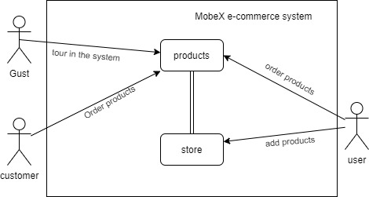

**Figure 1 – High level overview**

The e-commence system has three actors and one operation system. The gust can access the system and see the stores and product offed by them, the user and customer can see, bay and order a product form the stores, on the other hand the user can do the same thing as customer but he has the ability to add products to his store that he owns on the system. The actors can’t communicate with each other directly from the system.

## 2.2. Product functions